FS40 Pivot Bracket

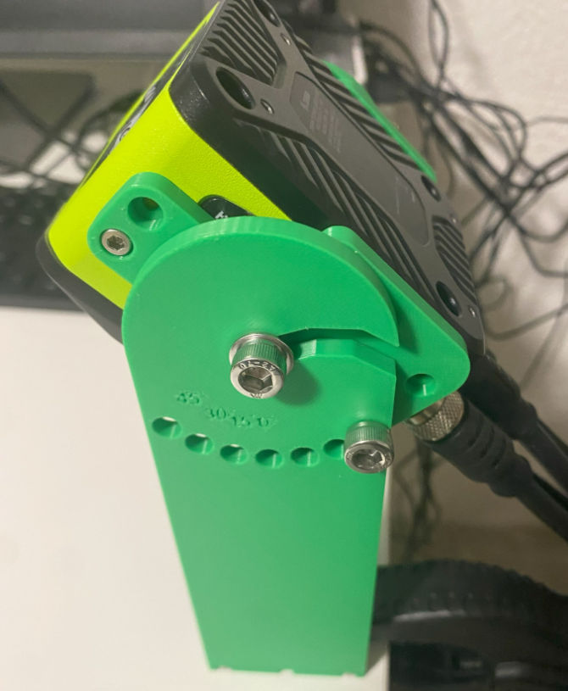

Camera drawings
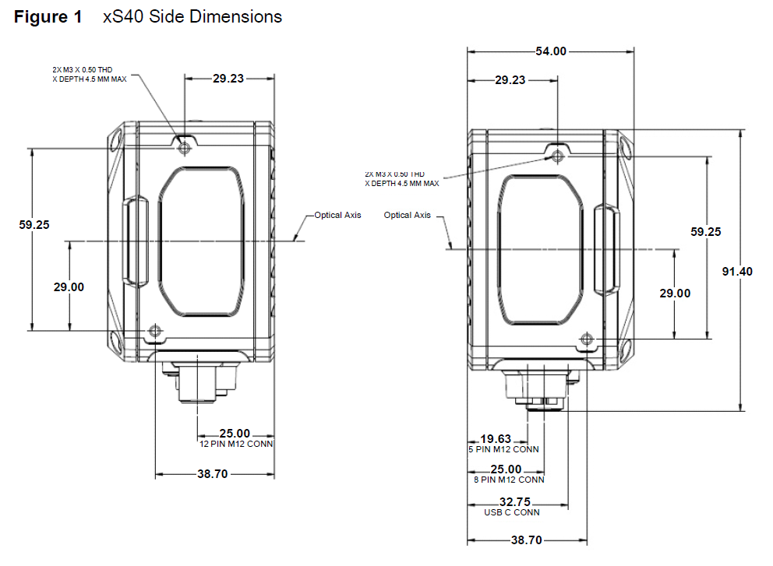

Adapter Plate
This plate is to connect to the camera side to the bracket creating a hinge centered around the camera optical axis
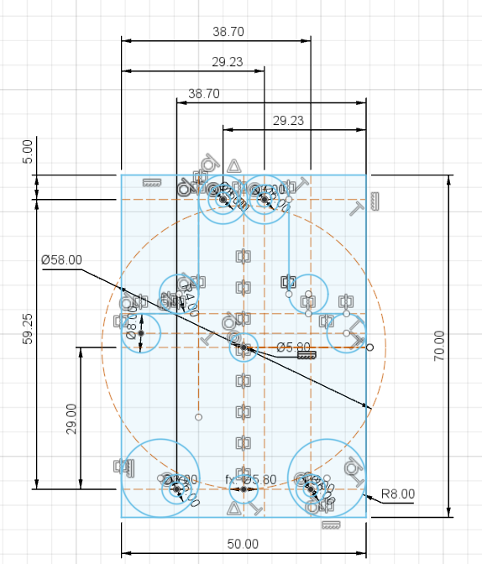

The bracket is symmetric and has twice the needed M3 holes just to use the same plate on both sides.
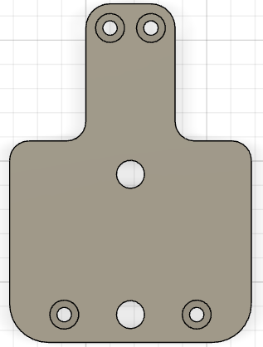 | 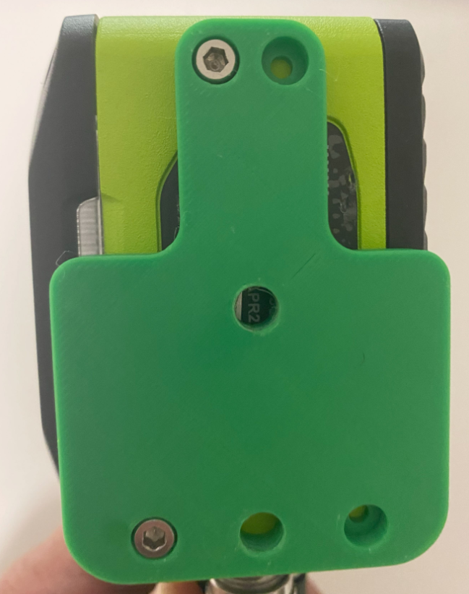

Base
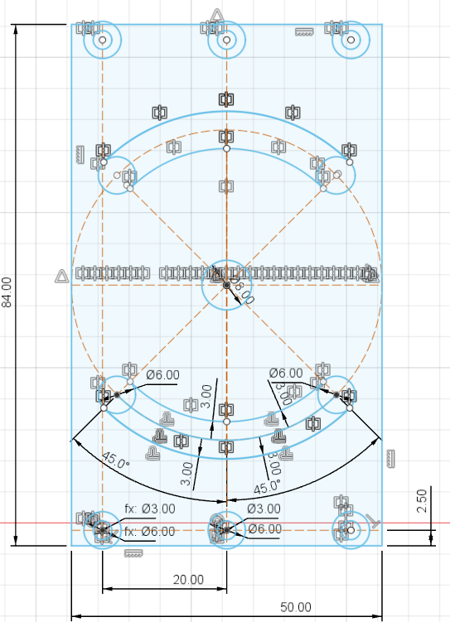

Final result
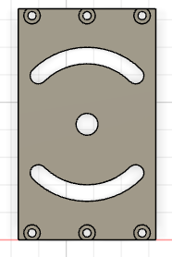

Shoulder
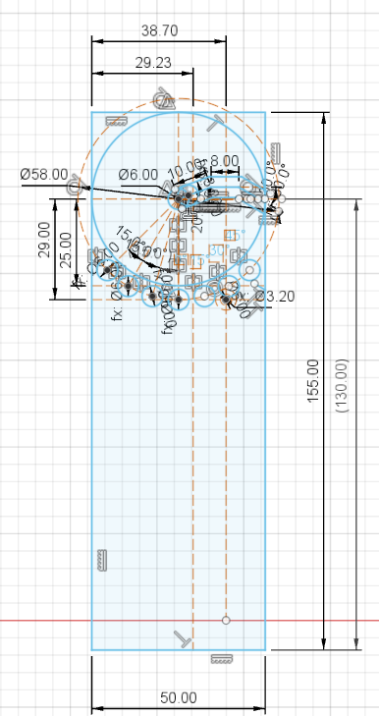

The pivot is made with 2 angles so the camera wouldn't fall down even with the brackets in vertical position. Two small teeth act as a stop block.
 | 
Embossed text indicate the rotation angle
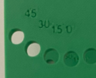

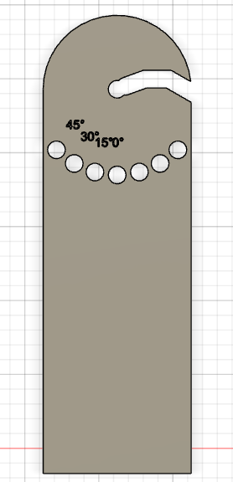 | 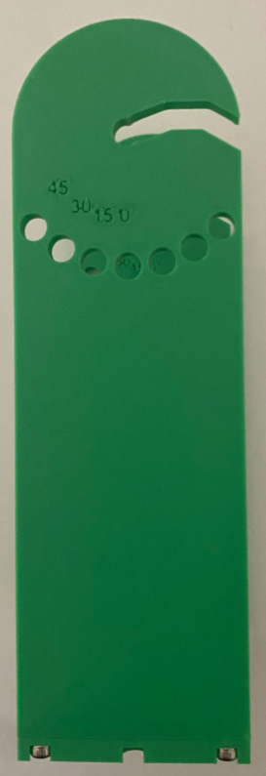

BOM
- M3 x 20 Screws: 6
- M3 x 10 Screws: 4
- M6 x 10 Screws: 4
- 6mm washers: 2
